# Lighthouse

# Expanded Learning Opportunities Program Plan

# Prepared by:

Lighthouse Community Charter and High School

444 Hegenberger Road

Oakland, CA 94621

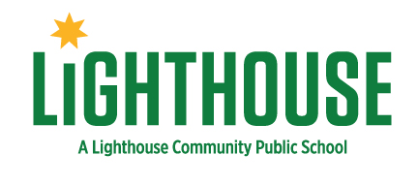

last updated 3.5.25

## Local Educational Agencies and Expanded Learning Opportunities Program Plan Sites

**Local Educational Agency (LEA) Name**:

Lighthouse Community Charter Public School

**Contact Name:** Giselle Hendrie

**Contact Email:** giselle.hendrie@lighthousecharter.org

**Contact Title:**  Director of Student Services

**Contact Phone:** 510-916-9800

**Instructions: Please list the school sites that your LEA selected to operate the Expanded Learning Opportunities Program (ELO-P). Add additional rows as needed.**

1. Lighthouse Community Charter Public School

**Governing Board Approval Date:**

**Review/Revision Date:**

**Review/Revision Date:**

**1—Safe and Supportive Environment**

**Physical Safety**

**Describe how the program will provide opportunities for students to experience a safe and supportive environment. Include if the program will be offered on the school site or off campus. If not onsite, describe where in the community it will be and how students will be supported to get there. Additionally, describe the elements such as staff training, incident reporting, and maintenance of health records.**

| The Lighthouse After School Program (ASP), including summer sessions, operates on-campus at Lighthouse, eliminating the need for transportation to and from the program. Students already on campus transition directly into ASP, arriving and departing via parent vehicles, local bus routes, or on foot from the adjacent neighborhood. Crossing guards and school staff provide safety oversight during arrival and dismissal.  Lighthouse prioritizes student safety with a locked, ADA-accessible, and securely enclosed campus. A full-time security guard is present during school hours and through ASP operations until 6:00 pm. Field trips utilize a trusted local transportation provider.  Alignment with School Policies & Staff TrainingASP follows the same emergency policies and procedures as the school day, ensuring seamless coordination. The After School Program Coordinator (ASPC) is part of the Leadership Team, working closely with school administrators to maintain a safe and supportive environment.  Health and Safety Measures   * Annual review and communication of health, safety, and behavior policies to staff, students, and families. * Mandatory family orientation sessions (offered in English and Spanish) to review safety protocols and behavior expectations. * Restorative Justice practices are used to address and repair harm; staff receive specialized training. * Incident reporting through an online system, with same-day communication to parents and relevant school staff.   Student Health and Emergency Preparedness   * Medical needs tracked in Aeries (Student Information System), with emergency contacts collected during registration. * CPR and First Aid training for all ASP and core day staff. * Sexual harassment and trauma-informed practice training for ASP staff, including mandatory reporting training for Child Protective Services. * Quarterly emergency drills (earthquake, evacuation, lockdown/active shooter) with post-drill debriefs to refine protocols.   Safety Protocols in Practice   * Uniformed students and staff identified by required lanyards. * Controlled campus access, with a visitor sign-in process ensuring only authorized adults enter. * Sign-in system tracking student locations throughout ASP. * Structured dismissal policies, with parent permissions required for departure methods. * Bus passes provided as needed for students with financial barriers to transportation.   Through these comprehensive measures, ASP ensures a safe, structured, and supportive environment for all participants, reinforcing student well-being both during and after school hours. |
| --- |

**Emotionally Safe & Supportive**

**Describe how the program provides an emotionally safe and supportive environment for students. This may include how the program incorporates social emotional learning.**

| The Lighthouse ASP is designed to provide a safe, nurturing, and inclusive environment that prioritizes students’ social-emotional, physical, and academic well-being. Grounded in research on expanded learning and protective factors, ASP intentionally fosters strong peer relationships, school attachment, and mentorship with trusted adults. This foundation creates a space where students feel valued, safe to take risks, and supported in their learning and personal growth.  The ASP integrates SEL principles into its daily operations, reinforcing Lighthouse’s core values of Integrity, Community, Love, Social Justice, and Agency. The program actively builds a culture of trust and inclusivity by:   * Training staff in Restorative Justice practices, which focus on repairing harm and fostering strong relationships. * Embedding SEL in daily interactions, ensuring students are welcomed, respected, and known well by their teachers and peers. * Providing leadership opportunities, clubs, and academic support, helping students develop a sense of belonging and purpose. * Employing many alumni of Lighthouse (Lighthouse’s sister school), ensuring staff understand the unique experiences and challenges students face.   ASP is committed to equity and inclusion, welcoming students of all backgrounds regardless of race, ethnicity, language, ability, or sexual orientation. As a public school program, ASP is open to all students, ensuring that every child has access to a safe and supportive after-school space. Strong family partnerships help prevent students from disengaging, as consistent expectations between the school day and ASP create a seamless support system. When additional needs arise, ASP connects families to healthcare, food security resources, and other community services. Holistic Student Development Beyond social-emotional support, ASP promotes students’ physical health and well-being through:   * Athletic programming, clubs, and league sports to encourage physical activity. * Healthy nutrition education and meal access in partnership with LunchMaster. * Referrals to external services when students and families require additional support.   With funding from the California Community Schools Partnership Program, Lighthouse has enhanced its Multi-Tiered System of Supports (MTSS) by expanding in-house staff to meet the growing emotional and special education needs of students. This investment further strengthens the ASP’s ability to provide a safe, supportive, and responsive environment.  Through intentional relationship-building, SEL practices, and comprehensive student support, ASP ensures that every student feels emotionally safe, connected, and empowered to succeed both academically and personally. |
| --- |

**2—Active and Engaged Learning**

**Explain how the program will provide opportunities for students to experience active and engaged learning that either supports or supplements, but does not duplicate, the instructional day.**

| The Lighthouse ASP extends the learning day by offering targeted, engaging activities that support—but do not duplicate—classroom instruction. Rooted in hands-on, project-based learning and informed by Beth Miller’s research on expanded learning, ASP is designed to foster academic success, personal development, and future career readiness.  ASP is structured around The Four Keys to College Readiness (Key Cognitive Strategies, Key Content Knowledge, Key Learning Skills and Techniques, and Key Transition Knowledge and Skills), as developed by David T. Conley. These principles guide programming to ensure students develop the necessary skills for high school, college, and career success.  To support students at all achievement levels, ASP offers:   * "Power Hour" academic support, where credentialed teachers and reading specialists provide homework assistance and skill-building. * Tier 2 interventions in literacy and math, designed for students needing remediation. * Personalized math and literacy remediation classes, ensuring students receive targeted support at their appropriate level.   ASP expands on the instructional day by embracing EL Education's project-based learning approach, which encourages students to take an active role in their education. Activities are designed to be authentic, relevant, and rooted in community needs, fostering critical thinking, creativity, and social responsibility.  Students engage in real-world projects, such as:   * Building community gardens * Volunteering at food banks * Training orphaned dogs * Creating public art on social issues like gun violence * Painting murals and designing furniture for the school   These hands-on experiences help students develop leadership, teamwork, and problem-solving skills, reinforcing classroom learning in meaningful, application-based ways.  ASP also promotes active learning through athletics and sports, which play a critical role in student engagement, well-being, and academic success. As a member of the Oakland Athletic League, Lighthouse offers:   * League and non-league sports, including soccer, basketball, volleyball, flag football, biking club, and running. * Physical activity as a tool for student motivation and retention, reinforcing the connection between participation in sports and academic achievement.   Beyond traditional academics, ASP integrates workforce development, "making," and design work to help students build technical and creative skills. These activities encourage entrepreneurship, innovation, and hands-on problem-solving, preparing students for future careers in STEM, trades, and creative industries.  By combining academic support, project-based learning, athletics, and workforce development, ASP supplements, rather than duplicates, the school day, ensuring students remain engaged, motivated, and equipped with essential life skills. Through authentic, hands-on experiences, students deepen their learning in ways that extend beyond the classroom, preparing them for long-term success. |
| --- |

**3—Skill Building**

**Detail how the program will provide opportunities for students to experience skill building.**

| The Lighthouse ASP is intentionally designed to provide students with opportunities to develop essential academic, social, creative, and life skills in a safe and supportive environment. Aligned with the core day, ASP complements, rather than duplicates, classroom learning, ensuring students engage in hands-on, meaningful skill development that prepares them for high school, college, and careers.  ASP provides targeted Homework Support and Academic Interventions to enhance students’ literacy, math, and study skills.   * Personalized academic support helps students strengthen core competencies in reading, math, and problem-solving. * Study skills development fosters independence and accountability in learning, addressing challenges like lack of home support for homework. * Literacy and Math Lab sessions on Wednesdays ensure students receive additional academic reinforcement. * Dual enrollment opportunities in partnership with the Peralta Community College District allow students to earn college credit while still in high school.   Through daily Enrichment Activities, students build valuable 21st-century skills such as critical thinking, creativity, collaboration, communication, and problem-solving.   * Project-based learning helps students engage in hands-on experiences that promote deeper learning and innovation. * Cultural exploration and identity development are integrated into enrichment classes, culminating in performances, projects, and exhibitions. * Student choice in enrichment activities allows them to explore their interests and develop agency, motivation, and leadership skills.  Sample Enrichment Classes by Skill Area:  * Fitness & Physical Development: Basketball, Soccer, Kickball, Track, Street Hockey * Creative & Artistic Expression: Photography, Graphic Design, 3D Printing, Cape Verdean Drumming * STEM & Technical Skills: Robotics, Ugandan Paper Bead Making, Orchestra * Cultural & Language Proficiency: Spanish for Native Speakers, Spanish for Spanish Learners * Performing Arts & Movement: Hip Hop Dance, Capoeira, Mexica (Aztec) Dance and Poetry   To promote physical and social-emotional well-being, ASP includes daily Recreation Time, where students participate in a structured rotation of:   * Recess & free play, promoting social skills and peer engagement. * Fitness & wellness activities, encouraging lifelong healthy habits. * Nutritious snacks, reinforcing good nutrition and well-being.   On Wednesdays, ASP expands opportunities for in-depth, student-driven projects and cultural experiences, such as:   * Theme-based activities that celebrate different cultures and traditions. * Project-based learning in the Making Space, where students develop technical skills in design, fabrication, and innovation. * Special literacy and math labs, providing targeted academic skill-building for students needing additional support.   By integrating academic support, creative enrichment, recreation, and college-readiness programs, ASP ensures that all students—especially those from underserved backgrounds—have access to the skills and resources necessary for long-term success.  Through data-driven programming, student choice, and hands-on experiences, ASP provides engaging, meaningful learning opportunities that empower students to develop essential skills for high school, college, and beyond. |
| --- |

**4—Youth Voice and Leadership**

**Describe how the program will provide opportunities for students to engage in youth voice and leadership. Consider and describe what opportunities youth have to lead activities or provide mentorship within the program. Address how youth are included in program quality assessment and improvement.**

| The Lighthouse ASP prioritizes youth voice and leadership, ensuring that students play an active role in shaping, improving, and leading program activities. Lighthouse’s core value of Agency promotes student leadership by encouraging students to take responsibility for what matters to them and empowering them to drive meaningful change within the program.  ASP is designed to meet the needs and interests of students, ensuring that programming remains engaging, relevant, and student-centered. Students have multiple structured opportunities to share feedback, propose ideas, and influence program decisions, including:   * Annual Insight Survey, where students provide feedback on program strengths and areas for growth, directly informing staff training, enrichment offerings, and academic support. * Student focus groups and shadowing, where school leadership actively listens to student experiences and responds with program adjustments. * Daily check-ins with ASP staff, allowing students to share real-time thoughts and concerns, sparking ideas that are discussed in ASP staff meetings and incorporated into program changes.   Through continuous feedback loops, ASP has already expanded cultural events, created affinity groups, and introduced enrichment activities—all initiated by student input. For example, student feedback led to the addition of quarterly cultural celebrations, such as Black History Month events and Dia de Los Muertos festivals.  ASP is intentionally structured to empower students as leaders in both program decision-making and peer mentorship. Opportunities for youth leadership include:   * Student Leadership Club, where students identify needs, propose activities, and plan initiatives that align with their interests. Past projects have included theater productions, gardening projects, Black History Month events, and demonstrations against gun violence. * Monthly community meetings, where students gather for announcements, public appreciations, and program feedback discussions. * Student-led activities on the first Wednesday of every month, where students design and facilitate projects for their peers.   ASP recognizes that student investment increases when they have a voice in program governance. Youth actively contribute to program assessment and quality improvement through:   * Quarterly student surveys, gathering insights on program effectiveness in supporting academic achievement and personal development. * Youth-led focus groups, where students discuss what’s working, what’s missing, and what changes should be made. * Ongoing leadership and governance roles, ensuring student perspectives guide programming decisions and long-term improvements.   ASP staff are trained in eliciting student voice through their facilitation and Restorative Justice practices, ensuring that every student feels heard, valued, and empowered. Additionally, students have autonomy in choosing activities that best fit their interests and goals, reinforcing ownership of their learning and development.  ASP’s commitment to youth voice and leadership makes it a responsive, student-driven program that fosters engagement, motivation, and personal growth. By integrating student-led decision-making, governance, and mentorship, ASP ensures that youth are active participants in shaping their own experiences, contributing to a stronger community, increased academic success, and a deeper sense of belonging.  With clear structures in place—such as the Student Leadership Club, focus groups, and monthly meetings—ASP empowers students with real agency and direct influence over the program, ensuring that it truly reflects their needs, passions, and aspirations. |
| --- |

**5—Healthy Choices and Behaviors**

**Explain how the program will provide opportunities for students to engage in healthy choices and behaviors. Include the plan to provide nutritious meals and snacks and how opportunities for physical activity will be provided.**

| The Lighthouse ASP prioritizes student health and well-being by integrating nutrition education, access to nutritious meals and snacks, and structured physical activity into daily programming. These components ensure that students develop lifelong healthy habits in a supportive and engaging environment.  ASP, in partnership with LunchMaster, provides free, healthy snacks that align with California Nutritional Guidelines and federal regulations to promote student health and reduce childhood obesity. Nutritious snacks are served daily and available for students needing an extra energy boost. Examples include:   * Hummus and carrots * Whole oranges, apples, and pears * Cheese sticks * Zac Attack bars * Nut-free cookies and milk   Additionally, LunchMaster hosts cooking workshops where students learn about nutrition, prepare healthy meals, and explore fun, hands-on cooking experiences with provided supplies and recipes.  ASP incorporates daily structured physical activity in alignment with California After School Physical Activity Guidelines, ensuring students engage in 30 to 60 minutes of movement each day. Activities are led by trained staff at a 20:1 ratio and include:   * Team sports and recreation, such as basketball, soccer, and flag football, using the campus track and field. * Fitness-focused enrichment classes, including martial arts, dance, yoga, and biking in partnership with Destiny Arts and the East Bay Regional Park District. * Healthy competitions, such as staff-student basketball or soccer games, promoting active engagement and positive role modeling.   Student fitness is monitored using the California Fitness Test, with annual evaluations guiding adjustments to programming to better support student health and development.  Through nutritious meal offerings, hands-on nutrition education, and structured daily physical activity, ASP ensures that students develop healthy habits that support their academic success and overall well-being. By fostering an active, nutrition-conscious culture, Lighthouse equips students with the tools they need to make healthy choices that will benefit them for a lifetime. |
| --- |

**6—Diversity, Access, and Equity**

**Describe how the program is designed to address cultural and linguistic diversity and provide opportunities for all students to experience diversity, access, and equity. Include how the ELO-P will provide access for students with disabilities.**

| The Lighthouse ASP is designed to honor, celebrate, and support the diverse cultural, linguistic, and ability backgrounds of all students. Lighthouse’s commitment to diversity, equity, and inclusion (DEI) is not just an aspiration—it is a foundational pillar of the program. The ASP ensures all students, including English Language Learners (ELLs) and students with disabilities, have full access to enriching opportunities that foster academic growth, social-emotional development, and cultural pride.  ASP is designed to reflect and uplift the diverse identities of its students, with intentional structures and programming that promote cultural representation, student leadership, and family engagement. Strategies include:   * Bilingual Access: All program materials, outreach, and communications are available in English and Spanish to ensure accessibility for ELL families. * Culturally Representative Staff: ASP prioritizes hiring staff from the local community who reflect students' backgrounds, with 100% of after-school staff identifying as people of color. Many staff members are bilingual and serve as cultural liaisons for students and families. * Student-Centered Cultural Events: ASP hosts school-wide celebrations such as Día de los Muertos, Black History Month, Juneteenth, National Hispanic Heritage Month, and Asian/Pacific Islander Heritage Month. Students and families co-lead these events, which include performances, traditional foods, and cultural education. * Culturally Responsive Teaching: Staff receive professional development on culturally relevant teaching practices, with training based on Zaretta Hammond’s Culturally Responsive Teaching and the Brain. This ensures that ASP values, affirms, and integrates students’ cultural backgrounds into learning experiences.   ASP is committed to ensuring students with disabilities receive the supports necessary to fully participate in all activities. Key supports include:   * Individualized Support Plans: ASP collaborates with the school’s Special Education team to provide Tier 2 interventions and integrate after-school activities into IEP and 504 plans. * Inclusive Learning Spaces: Students with disabilities participate in mixed-ability classrooms, receiving appropriate accommodations without being tracked or separated based on ability level. * Counseling and Social-Emotional Support: Students who require additional emotional or behavioral support have access to on-campus counseling and therapy through ASP. * Physical Accessibility: The ASP site is fully accessible, ensuring that students with disabilities can navigate all learning environments without barriers.   ASP has built intentional outreach and enrollment strategies to ensure students from historically marginalized backgrounds, including English Learners, unhoused youth, and students with disabilities, have equitable access to program offerings.   * Program Awareness & Promotion: ASP enrollment is actively promoted during registration, at back-to-school events, and through parent conferences. * Lottery Preferences for Unhoused Students: Lighthouse has adjusted enrollment preferences to give priority to students experiencing homelessness. * Community Partnerships: ASP partners with Destiny Arts Center to provide movement and performing arts programming, which includes Hip Hop, African Dance, Drumming, and Martial Arts—helping students explore identity and culture through creative expression.   ASP fosters an environment where students feel seen, valued, and empowered to embrace their identities. Core elements include:   * Daily Crew Meetings and Real Talk Wednesdays, where students discuss their experiences and build cross-cultural understanding. * Student Leadership in Cultural Celebrations, ensuring events are student-driven and authentically represent their lived experiences. * Challenge Day Activities, which create safe spaces for students to share personal experiences and deepen connections across differences. |
| --- |

**7—Quality Staff**

**Staff Engagement**

**Detail how the program will provide opportunities for students to engage with quality staff.**

| The Lighthouse ASP prioritizes staff quality as a key driver of program success and student outcomes. By ensuring that staff are highly qualified, diverse, and deeply connected to the community, ASP fosters a supportive and enriching environment where students can engage with caring, knowledgeable mentors who reflect their backgrounds and lived experiences.  ASP maintains strict hiring standards to ensure that students are supported by competent, skilled professionals:   * Minimum education requirement: All staff must have completed at least an AA degree, with 60% exceeding this requirement by holding a four-year college degree. * Rigorous hiring process: Only candidates who meet minimum education and experience requirements are interviewed, ensuring a high level of professionalism and expertise in all program staff.   ASP believes that students thrive when they see themselves reflected in the adults who guide them. As such, ASP works diligently to recruit and retain a diverse staff that mirrors the student population.   * 100% of ASP staff are people of color and/or from the same neighborhoods as the students they serve. * Recruitment strategies include outreach through job fairs, universities, teacher-training programs, social media, and community events. * Staff are encouraged to bring their full selves to work, sharing their experiences, knowledge, and interests with students to build a strong, authentic community.   The program provides multiple opportunities for students to engage with staff in meaningful ways, fostering mentorship, trust, and personal growth:   * Daily check-ins, where students and staff build relationships, discuss challenges, and celebrate successes. * Safe spaces for discussion, including conversations about social justice issues impacting the Oakland community. * Opportunities for student-staff collaboration, with staff leading clubs, activities, and special events aligned with student interests.   To ensure continuity and stability for students, ASP employs strategies to retain top talent, including:   * Opportunities for professional development, leadership roles, and upward mobility. * Competitive pay, benefits, and retention bonuses to attract and retain dedicated educators. * Staff appreciation events and celebrations, fostering a positive and supportive workplace culture. |
| --- |

**Minimum Staff Qualifications**

**What are the minimum qualifications of an instructional aide pursuant to the policies of the LEA? Describe the process for health and safety screening for staff. Describe how your program will maintain minimum staffing ratios. (See [EC Section 46120(b)(2)(D)]).**

| To ensure high-quality instruction and student support, all instructional aides in the ASP must meet the minimum qualifications established by the Local Educational Agency (LEA):   * Completion of an Associate’s Degree (AA) or higher * Demonstrated experience working with students in an educational or youth development setting * Commitment to the Lighthouse mission of equity, inclusion, and social justice   Currently, 60% of ASP staff exceed the minimum requirement and have completed a four-year college degree.  To ensure a safe and secure environment for all students, ASP follows a comprehensive health and safety screening process for all staff:   * Fingerprinting and Background Checks: All employees must pass a Live Scan background check through the California Department of Justice (DOJ) and Federal Bureau of Investigation (FBI). * Tuberculosis (TB) Testing: Staff must provide proof of a negative TB test before employment. * First Aid & CPR Certification: All ASP staff receive First Aid and CPR training and must maintain up-to-date certification. * Mandated Reporter Training: Staff are trained to recognize and report child abuse and neglect in compliance with California Child Abuse and Neglect Reporting Act.   ASP maintains appropriate staffing ratios to ensure student safety and high-quality supervision:   * 1:20 ratio for general programming, in compliance with California After School Education and Safety (ASES) Program guidelines. * Additional support staff for students with disabilities and English Language Learners (ELLs), ensuring equitable access and engagement. * Quarterly evaluations to monitor staff performance and maintain safe, effective supervision. |
| --- |

**Staff Development**

**Describe your staff training and development plan. Include the tools and resources offered to staff to provide them with the competencies needed to engage and enrich students. LEAs operating ASES, 21st CCLC, and/or the ELO Program, may close program to offer up to 3 days of staff development. This activity is allowable during the instructional days or the nonschooldays. (See [EC Section 46120(b)(8)]).**

| A high-quality after-school program depends on well-trained, engaged, and continuously growing staff. ASP has built a robust, ongoing professional development (PD) program that ensures staff are well-equipped to support, engage, and enrich students.  All new ASP staff undergo a comprehensive onboarding process designed to align them with the program’s mission and expectations. This includes:   * Restorative Justice Training, ensuring staff can foster positive student relationships and resolve conflicts effectively. * Culturally Responsive Teaching, based on Zaretta Hammond’s work, equipping staff to engage diverse learners. * Trauma-Informed Practices, in partnership with Seneca Family of Agencies and the Lighthouse MTSS team, to create safe and supportive environments for all students. * Health and Safety Protocols, including CPR/First Aid training and emergency preparedness.   ASP is committed to continuous learning and staff growth, providing:   * Weekly Staff Meetings: Staff celebrate successes, discuss challenges, and receive “quick fix” PD sessions (e.g., educational articles, team-building activities, behavior management strategies). * Quarterly PD Days:   + One day with the full K-12 Lighthouse Community Charter School staff to align after-school and school-day practices.   + One day specifically for ASP staff, focused on best practices in youth development, social-emotional learning (SEL), and student engagement. * Quarterly Observations & Feedback: Staff receive structured feedback from program leadership, helping them refine their teaching strategies. * External Training & Partnerships: ASP collaborates with:   + California School Age Consortium (CalSAC) for youth development best practices.   + EL Education for project-based learning and student-engaged assessment.   + Region IV After School Programs for high-impact instructional strategies.   ASP staff are expected to master the following Core Competencies:   * Demonstrates Social Justice and Equity in Education * Expects and Facilitates High-Quality Student Engagement * Creates a Positive & Inclusive Culture * Responds Effectively to Student Needs * Develops Meaningful Relationships with Students, Parents, and Colleagues * Models Professionalism & Growth Mindset   To retain high-quality staff and promote leadership growth, ASP offers:   * Opportunities for Advancement within the program (e.g., transitioning from instructional aide to program coordinator). * Staff-Led Decision-Making: Staff help shape program direction by providing regular feedback and leading student-centered initiatives. * RetentionIncentives, including competitive pay, benefits, and appreciation events. |
| --- |

**8—Clear Vision, Mission, and Purpose**

**Explain the program’s clear vision, mission, and purpose.**

| Vision The Lighthouse ASP is dedicated to transforming the educational landscape for historically underserved students in Oakland. We believe that academic success, social-emotional well-being, and equitable access to opportunity are fundamental rights for all students. Our vision is to create a responsive, student-centered environment where every student—regardless of race, income, or background—has the support, skills, and confidence to pursue higher education and a fulfilling career. Mission Our mission is to prepare students for the college and career of their choice by:   * Providing individualized academic support, ensuring students master content and develop essential college-ready soft skills, including time management, goal setting, and self-advocacy. * Offering enrichment classes that help students explore their identities, interests, and potential career paths, balancing academic rigor with creative expression and personal growth. * Creating a trauma-informed environment, with integrated social-emotional supports for students who have experienced significant adversity. * Ensuring equity and inclusion, with targeted initiatives like the African American Male Achievement Initiative to close opportunity gaps and support leadership development.  Purpose & Commitment to Student Success The Lighthouse ASP exists to counter alarming national and local educational disparities:   * Only 14% of Latino students nationwide earn a bachelor’s degree. * In Oakland, only 72% of African American and 69% of Latino students graduate high school in four years, with 22% dropping out before graduation. * 47% of Lighthouse students are English Learners, requiring specialized academic and language support. * Over 25% of Lighthouse students have elevated or extremely elevated trauma risk factors.   In response to these challenges, ASP is designed to be a lifeline of support, enrichment, and empowerment for students. Our program:   * Provides wraparound services through partnerships with Seneca, the LCPS Clinical Team, and the LCPS Special Education Team to offer counseling, therapy, and behavioral support. * Emphasizes project-based learning with programs like Making, Art, and Design (MAD), where students gain real-world skills in robotics, woodworking, welding, and programming. * Fosters student agency and independence, helping students develop the resilience, leadership, and academic skills necessary to succeed in college and beyond.   Through a strong partnership between families, teachers, and after-school staff, the Lighthouse ASP ensures that every student receives the academic, social, and emotional support they need to reach their fullest potential. |
| --- |

**9—Collaborative Partnerships**

**Students and Families**

**Describe how students and families were involved in the creation of the program plan and how they are engaged throughout the year.**

| The Lighthouse ASP was designed with direct input from students and families to ensure it meets their needs and interests. Lighthouse is deeply committed to fostering a collaborative school culture, where families, students, and staff co-create learning opportunities that support student success. How Students and Families Were Involved in Program Creation ASP leaders conducted focus groups, surveys, and direct student feedback sessions to shape the program’s offerings. The program’s academic assistance element was designed based on student feedback, including:   * More individualized academic support for students who struggle with homework completion and college readiness soft skills (e.g., time management, goal setting, and self-advocacy). * Flexible learning options, including study groups, peer mentoring, and one-on-one tutoring, ensuring students can choose the learning style that best supports their needs. * Expanding enrichment opportunities such as art, dance, music, and leadership activities that help students develop self-worth and balance academic rigor with creative expression.   Families also played a critical role in shaping ASP’s vision. Lighthouse’s family engagement strategies include:   * Annual Insight Surveys, where parents share their needs and preferences for after-school programming. * Quarterly family meetings, where ASP leaders present program updates and solicit feedback on how to enhance student experiences. * Parent Advisory Committees, allowing families to co-develop community events, cultural celebrations, and literacy initiatives. * Ongoing parent-staff communication through student-led conferences, newsletters, and bilingual outreach.   As a direct result of family input, ASP has:   * Expanded social-emotional support services by increasing counseling and therapy partnerships for students experiencing trauma. * Strengthened cultural programming, adding quarterly events celebrating Black, Latinx, and Asian/Pacific Islander heritage. * Increased enrichment offerings to include more college and career exploration activities aligned with student interests. |
| --- |

**Community Based Organizations and other Non-LEA Partners**

**Describe how the LEA engaged Community Based Organizations and other non-LEA partners to design the program plan and how they will be included in the administration/implementation of the program. Include how ELO-P will be coordinated with other initiatives such as Community Schools, Multi-Tiered Systems of Support.**

| The Lighthouse ASP is designed to integrate seamlessly with community-based organizations (CBOs) and other non-LEA partners, ensuring students receive comprehensive academic, social, and enrichment support.  ASP collaborates with a range of organizations to provide enrichment activities, academic support, and wellness programming:   * EL Education: ASP aligns with EL’s project-based learning model, which provides students with real-world, hands-on learning opportunities. EL coaches provide ongoing professional development for ASP staff to ensure high-quality instructional practices. * LunchMaster: Provides healthy snacks and nutrition education, including occasional student cooking workshops. * Oakland Athletic League: Offers a structured network for competitive and recreational sports, including basketball, soccer, and flag football. * Girl Scouts & Boy Scouts of America: Provide youth development programs that promote leadership, service, and personal growth. * Families in Action for Quality Education: Provides family literacy programming, equipping parents with strategies to support student reading proficiency at home.   ASP is actively building new partnerships that will further enrich student experiences:   * Bay Area Mural Project: A 9-week curriculum where students design and create a mural, fostering community pride and creative expression. * Planting Justice: Introduces students to urban gardening, food justice, and healthy cooking, reinforcing hands-on environmental education. * East Bay SPCA: Provides animal therapy and rescue dog programs, allowing students to engage with support animals during study times.   ASP is fully aligned with Lighthouse’s Community Schools model and Multi-Tiered Systems of Support (MTSS) to ensure students receive academic, behavioral, and social-emotional interventions tailored to their needs:   * Tiered academic interventions: Students identified for additional academic support (e.g., struggling readers, ELLs, students with IEPs) receive personalized learning plans and small-group tutoring within ASP. * Social-emotional support through Seneca & LCPS Clinical Team: Students with high-risk trauma scores receive in-school and after-school counseling, ensuring continuity of care. * African American Male Achievement Initiative: ASP plans to launch this initiative to increase literacy, attendance, and leadership skills for Black male students identified for Tier 2 support. * Seamless coordination between school-day and after-school staff: ASP tutors meet with core teachers daily to track student progress and ensure alignment between instructional day interventions and after-school support. |
| --- |

**10—Continuous Quality Improvement**

**Describe the collection and use of student social, behavioral, or skill development data to support CQI, to engage in reflection and be intentional about program management practices and activities delivered to students. Data outcomes may relate to specific social-emotional competencies, including, but not necessarily limited to, social skills, self-control, academic mindset, perseverance, conflict resolution, and school c**onnectedness. More information on CQI can be found on the CDE Quality Standards and CQI web page, as previously provided.

| The Lighthouse ASP is built on a Continuous Quality Improvement (CQI) model that ensures data-driven decision-making at every level, from student growth and program effectiveness to staff development and strategic planning. By systematically collecting and analyzing student social, behavioral, and skill development data, ASP can identify strengths, address challenges, and refine programming to best support student success. Data Collection & Social-Emotional Learning (SEL) Metrics ASP collects quantitative and qualitative data from multiple sources to assess student social-emotional competencies, behavioral trends, and academic development. These data points inform program improvements, intervention strategies, and professional development for staff.   * Behavioral & Social-Emotional Data   + AimswebPlus BASC-3 BESS Screener: Measures student trauma risk factors and identifies students needing additional social-emotional support. Over 25% of Lighthouse students are flagged as having elevated or extremely elevated risk, guiding individualized intervention plans.   + Student Experience Surveys (Fall & Spring): Tracks student school connectedness, self-efficacy, and sense of belonging within ASP.   + Behavior Logs & Restorative Justice Tracking: Monitors student conflict resolution skills, disciplinary incidents, and positive behavioral trends. ASP has a goal of reducing suspension rates to below 2% across all student groups.   + Insight Surveys & Focus Groups: Gathers student perspectives on program effectiveness, leadership opportunities, and engagement levels. * Academic Mindset & Skill Development Data   + Student Achievement Data: Includes SBAC state assessment results, literacy and math intervention progress, and A-G completion rates. ASP aims to increase the percentage of students meeting/exceeding standards by 10% annually.   + Study Skills & Goal-Setting Data: Tutors and mentors assess students’ time management, help-seeking behavior, and perseverance in academic sessions.   + College & Career Readiness Metrics: ASP tracks the percentage of students earning dual enrollment credits and participating in career exploration enrichment. The goal is for 80% of students to earn at least 9 units of college credit before graduation. * School Engagement & Attendance Data   + Daily Attendance & Chronic Absenteeism Tracking: ASP works toward an attendance goal of 96%+ across all student groups, aligning with LCPS strategic priorities.   + Affinity Group Participation Data: Tracks participation in cultural events, leadership clubs, and African American Male Achievement Initiative to ensure equitable access to enrichment opportunities.  How Data is Used to Improve ASP Practices1. Continuous Improvement Cycle: Assess, Plan, Do ASP follows a structured CQI cycle that incorporates real-time data reflection, goal setting, and programmatic adjustments:   2. Using Data to Address Equity Gaps  * Student Affinity & Inclusion Initiatives:   + When ASP identified lower participation rates among Black students, leadership analyzed attendance data, interviewed families, and implemented the African American Male Achievement Initiative, creating dedicated affinity spaces and mentoring programs.   + Outcome: Increased engagement, attendance, and sense of belonging. * Targeted Academic & SEL Interventions:   + Students flagged by the BASC-3 BESS screener are referred to Seneca clinicians or school counselors for individual and group therapy.   + Students needing Tier 2 academic interventions receive additional one-on-one tutoring and study skills coaching.   + Outcome: Increased student self-efficacy, resilience, and academic engagement. * Expanding College & Career Readiness:   + Student surveys revealed a need for stronger career exploration and leadership development.   + ASP introduced new enrichment pathways in Making, Art, and Design (MAD), financial literacy, and workforce training.   + Outcome: More students exploring career-aligned enrichment and earning college credits through dual enrollment.   The Lighthouse ASP is a data-driven, student-centered program that actively uses social, behavioral, and academic development metrics to refine its practices, improve student outcomes, and close opportunity gaps. By embedding Continuous Quality Improvement (CQI) practices, ASP ensures that all students—regardless of race, income, or background—receive the support, resources, and opportunities they need to succeed. |
| --- |

**11—Program Management**

**Policies and Procedures**

**Include as an addendum (or hyperlink) any approved program policies, procedures, or manuals. This should include documentation and record-keeping practices, including enrollment/registration, attendance tracking, etc.**

| 1. Program Policies & ProceduresA. Enrollment & Registration  * Eligibility: Open to all TK-12 Lighthouse students, with priority given to students requiring academic interventions, English Language Learners (ELLs), students with disabilities, and students experiencing homelessness. * Outreach & Recruitment:   + Multi-language communication (English/Spanish) via school newsletters, parent emails, text messages, and community meetings.   + Promotion at IEP and 504 meetings to ensure equitable access for students with disabilities. * Enrollment Process:   + Parents complete online or paper registration forms available at the school office and website.   + Student data is entered into the Student Information System (SIS) to track attendance and engagement.  B. Attendance Tracking & Documentation  * Daily Attendance Monitoring:   + Staff track student participation using the Aeries Student Information System.   + Parents are notified if students miss two or more consecutive days without prior notice. * Chronic Absenteeism Prevention:   + ASP aligns with LCPS strategic priorities to reduce chronic absenteeism by 2% annually.   + Students at risk of frequent absences receive targeted support through mentorship, affinity groups, and family outreach.  C. Staffing & Leadership Structure ASP ensures effective program administration and alignment with the core school day through a structured leadership team:  D. Financial Policies & Resource Allocation   * Staff Salaries:   + Base rate of $20/hour, with boosts for advanced degrees, bilingual skills, and alumni status.   + Medical benefits covered 100% for staff working 0.75 FTE or more.   + 8% retirement match provided by the school. * Program Budget Allocation:   + Books and supplies: $15,000 annually.   + Staff professional development and retention initiatives.  2. Documentation & Record-Keeping Practices ASP maintains meticulous records to ensure compliance, program effectiveness, and student success. A. Student Data Management  * Student Information System (Aeries):   + Tracks attendance, academic progress, behavioral interventions, and student participation in enrichment activities. * Annual Performance Reports (APR):   + Submitted to the California Department of Education (CDE) to ensure compliance with Expanded Learning Opportunity Program (ELO-P) requirements.  B. Staff Training & Professional Development Records  * Quarterly Professional Development Retreats:   + Full-day PD sessions covering Restorative Justice, racial equity training, and lesson planning. * Weekly Staff Meetings & Daily Huddles:   + Topics include CalSAC training modules, social-emotional learning (SEL), and classroom management strategies. * Professional Growth Plans:   + Each staff member sets CQI-aligned goals and receives regular performance evaluations.  C. Continuous Quality Improvement (CQI) Documentation  * CQI Cycle Implementation:   + April–June: Analyze student achievement and program participation data.   + July: Leadership retreat sets CQI goals for the year.   + August–June: Ongoing data collection, staff training, and mid-year adjustments. * Data-Driven Decision-Making:   + SBAC scores, BASC-3 BESS screenings, and student experience surveys inform program adjustments.  3. Coordination with Community Partners & Compliance Reporting ASP collaborates with community-based organizations (CBOs) and non-LEA partners to provide enrichment activities and academic support. A. Key Partnerships  * EL Education: Supports project-based learning professional development. * LunchMaster: Provides nutritious snacks and student cooking workshops. * Oakland Athletic League: Organizes basketball, soccer, and flag football programs. * Families in Action for Quality Education: Supports family literacy initiatives. * Seneca Family of Agencies: Provides trauma-informed student counseling.  B. Compliance & Reporting  * Annual Reports to CDE & LCPS Board:   + Includes attendance data, student performance metrics, and budget allocations. * Data Transparency:   + Families receive quarterly updates on student progress and program improvements.  4. Communication & Program Transparency ASP prioritizes clear, consistent communication with staff, families, and stakeholders:   * Monday Minute Newsletter: Weekly update for staff on program happenings and priorities. * Monthly Family Updates: Includes event announcements, student spotlights, and feedback opportunities. * Student Leadership & Advisory Meetings: Ensures youth voice is central to program decision-making. |
| --- |

**Budget**

**Provide your budget for the program including cost-share items. The LEA is required to ensure all costs charged to the program are reasonable, necessary, and allowable in accordance with applicable statutes, regulations, and program plans for the Expanded Learning Opportunities Program3. How does this budget reflect the needs of students and families within the community?**

| The Lighthouse ASP budget is structured to ensure that students receive high-quality academic support, enrichment activities, and social-emotional services. Given that 89.7% of students are low-income and 47% are English Learners, the budget is designed to provide equitable access to remediation, enrichment, and support services that address the needs of historically underserved students and families.   How the Budget Reflects Student & Community Needs1. Prioritizing Academic Remediation & College Readiness  * $93,000 for certificated teachers ensures that students struggling with literacy, math, and other core subjects receive targeted interventions to close achievement gaps. * Personalized tutoring and study skills coaching help students develop self-efficacy, time management, and help-seeking behaviors, supporting their college and career readiness.  2. Investing in Highly Qualified & Diverse Staff  * $150,137 for classified personnel ensures that ASP can recruit and retain a diverse team of teachers, mentors, and paraprofessionals who reflect the cultural and linguistic diversity of students. * Staff salaries include boosts for bilingual proficiency, advanced degrees, and alumni status, reinforcing representation and cultural competence.  3. Supporting Staff Well-Being & Retention  * $33,143 for employee benefits guarantees that expanded learning staff receive medical coverage and retirement contributions, reducing turnover and ensuring students build long-term relationships with trusted mentors. * Staff who work 0.75 FTE or more receive 100% paid medical benefits, ensuring their well-being and commitment to student success.  4. Ensuring Access to Enrichment & Social-Emotional Learning  * $10,000 for books, supplies, and enrichment materials provides funding for:   + Culturally responsive learning resources that support ELLs and students with disabilities.   + STEM and arts materials for hands-on enrichment activities.   + Social-emotional learning (SEL) tools, including restorative justice circles and affinity group resources.   The budget is directly aligned with the needs of Lighthouse’s diverse student population, ensuring that:   * Students receive targeted academic intervention and remediation. * Families have access to high-quality after-school programs that support working parents. * Teachers and staff are well-compensated, leading to staff retention and strong student-adult relationships. * Students engage in meaningful enrichment activities that promote creativity, self-expression, and career exploration.   This strategic allocation of funds ensures that every student, regardless of background, has the opportunity to thrive academically, socially, and emotionally in a safe, inclusive, and enriching learning environment. |
| --- |

**Provide a detailed description of how the LEA will ensure the proper implementation of the above requirements.**

| The Lighthouse ASP operates within a structured framework to ensure that all program requirements are properly implemented, monitored, and continuously improved. The Local Educational Agency (LEA)—Lighthouse Community Public Schools (LCPS)—utilizes data-driven decision-making, strategic leadership oversight, and accountability systems to guarantee high-quality program delivery. 1. Leadership Oversight & AccountabilityA. Organizational Leadership Structure The ASP is supervised and managed by an Organizational Leadership Team, which ensures alignment with the school day, staff effectiveness, and program compliance.  B. Weekly, Quarterly, and Annual Monitoring   * Weekly leadership meetings to review program operations, staff concerns, and student engagement data. * Quarterly staff retreats ensure alignment around program goals and professional development. * Annual reports to the LCPS Board and California Department of Education (CDE), including attendance, student achievement, and financial audits.  2. Staff Hiring, Training, and DevelopmentA. Ensuring High-Quality, Diverse Staffing  * Recruitment of highly qualified staff through job fairs, teacher training programs, and community partnerships. * Competitive compensation, including salary boosts for bilingual skills, advanced degrees, and alumni status. * Retention incentives, including full medical benefits for staff working 0.75 FTE or more and an 8% retirement match.  B. Professional Development for Program Success ASP implements comprehensive professional development to ensure staff are equipped to engage and support students. Training includes:   * Restorative Justice and Trauma-Informed Practices (in partnership with the Seneca Family of Agencies). * Culturally Responsive Teaching (based on Zaretta Hammond’s model). * Social-Emotional Learning (SEL) and Youth Development using Cal-SAC training modules. * Weekly staff meetings for planning, training, and communication. * Quarterly professional development retreats focused on equity, inclusion, and program improvement.  3. Continuous Quality Improvement (CQI) Process  * ASP follows a structured CQI cycle (Assess, Plan, Do) to monitor student success and program effectiveness. * ASP uses multiple forms of data to track student progress, social-emotional learning (SEL), and behavioral outcomes.  4. Fiscal Responsibility & Budget Implementation The ASP budget is designed to maximize student impact while ensuring fiscal responsibility. 5. Community Partnerships & Collaboration ASP collaborates with Community-Based Organizations (CBOs) and local partners to expand student learning opportunities. 6. Compliance, Documentation & Reporting ASP adheres to all state and district compliance requirements, including:   * Annual Performance Reports (APR) to CDE, detailing program effectiveness and financial accountability. * Quarterly Board Reports, tracking attendance, student engagement, and CQI progress. * LCPS Audits & Financial Reviews, ensuring transparency in budget allocation and resource utilization.  A. Record-Keeping Practices  * Aeries Student Information System: Manages attendance, student progress, and intervention tracking. * Staff Training Logs: Maintains records of PD hours and certifications. * CQI Data Dashboards: Used by leadership to assess trends and inform program decisions.   The Lighthouse ASP ensures proper implementation through structured leadership, continuous data analysis, strong fiscal management, and strategic community partnerships. By embedding rigorous accountability measures and aligning program goals with student needs, ASP guarantees that students receive the academic, social-emotional, and enrichment support necessary for long-term success. |
| --- |

## General Questions

### Existing After School Education and Safety (ASES) and 21st Community Learning Centers (21st CCLC) Elementary and Middle School grantees

ASES, 21st CCLC Elementary/Middle School, and the ELO-P should be considered a single, comprehensive program. In coordinating all these funding streams to move towards a single program, the expectation is that the most stringent programmatic requirements will be adopted for program guidance.

Do you have an ASES Grant? **X**Yes ☐ No

Do you have a 21st CCLC Grant? **X** Yes No

(Lighthouse has an ASSETs grant, but not a 21st CCLC Grant)

If one or both grants are held, describe how these funding sources will be leveraged with the ELO-P funding to create one comprehensive and universal Expanded Learning Program.

The Lighthouse ASP leverages ELO-P funding in combination with other funding sources to create a comprehensive and universal Expanded Learning Program that provides robust opportunities for students. Each funding source plays a critical role in ensuring the program meets academic, social-emotional, and enrichment needs for all students.

#### Building a Fully Comprehensive Program Neither ELO-P funding nor other sources alone would be sufficient to fully sustain the program. By combining resources, Lighthouse is able to: - Expand academic support: Providing targeted remediation, intervention, and enrichment opportunities. - Foster enthusiasm and participation: Delivering engaging programming that keeps students motivated and eager to attend. - Support greater student achievement: Aligning expanded learning with school-day goals to ensure students are prepared for success in college and careers. By integrating multiple funding sources, Lighthouse creates a seamless, fully built program that not only supports student success but also ensures the sustainability and growth of its Expanded Learning Program.

### Transitional Kindergarten and Kindergarten

Programs serving transitional kindergarten or kindergarten pupils shall maintain a pupil-to-staff member ratio of no more than 10 to 1. (See [EC Section 46120(b)(2)(D)]). Please address the proposed schedule and plan for recruiting and preparing staff to work in the program, including supporting them to understand how to work with younger children. How will the lower pupil-to-staff ratio be maintained? How will the curriculum and program be developmentally informed to address this younger age group?

To maintain a pupil-to-staff ratio of no more than 10:1 for transitional kindergarten (TK) and kindergarten pupils, our program will implement the following strategies:

**Staff Recruitment and Preparation:**

- Recruitment Plan: We will actively recruit educators with experience in early childhood education, focusing on individuals who demonstrate a passion for working with younger children.

- Professional Development: Staff will participate in specialized training sessions to enhance their understanding of developmental milestones and effective teaching strategies for young learners.

**Maintaining Lower Pupil-to-Staff Ratios:**

- Classroom Staffing: Each TK and kindergarten classroom will be staffed by qualified staff, ensuring compliance with the required 10:1 ratio.

- Ongoing Monitoring: We will regularly assess classroom sizes and adjust staffing as needed to maintain appropriate ratios throughout the academic year.

**Developmentally Informed Curriculum:**

- Curriculum Design: Our curriculum will be tailored to meet the developmental needs of young children, incorporating play-based and hands-on learning activities that promote cognitive, social, and emotional growth.

- Continuous Assessment: Educators will utilize formative assessments to monitor student progress and adapt instruction to support individual learning needs effectively.

By implementing these measures, we aim to create a supportive and enriching learning environment that caters to the unique needs of our youngest learners.  

### Offer and Provide Access

Describe how your LEA will offer ELO-P to their pupils and families using culturally and linguistically effective/appropriate communication channels. Describe how your LEA will provide access to the ELO-P by describing the enrollment process. Include the distribution of the form, signature process, and how the forms are stored. Will transportation be provided?

The Lighthouse ASP is designed to ensure equitable access for all students and families, with a focus on culturally and linguistically effective communication and inclusive enrollment processes.

**Culturally and Linguistically Appropriate Communication Channels**

Recognizing the diversity of our community, ASP ensures that all communication is accessible to English Language Learners (ELLs) and other underserved groups:

- Bilingual Materials: All program materials, including advertising, registration forms, and program updates, are translated into English and Spanish.

- Community Outreach: The program is promoted through emails, text messages, community meetings, and weekly announcements to ensure families receive consistent and clear information.

- Culturally Responsive Events: ASP hosts school-wide celebrations such as the Black Excellence Celebration, Latinx Heritage Celebration, and BSU Club Dinner, providing opportunities for families to connect and feel welcomed.

- Bilingual Staff: Staff members who speak the community's languages are employed to ensure families can communicate comfortably and receive the support they need.

**Enrollment Process**

The enrollment process for ASP is designed to be inclusive, efficient, and accessible for all families:

**Invitation to Participate**

All students are invited to participate in ASP, with priority given to:

- Students with disabilities.

- ELLs.

- Students experiencing homelessness.

- Students needing Tier 2 interventions.

**Distribution of Materials**

Registration materials are distributed through:

Emails, school newsletters, and community meetings.

In IEP and 504 meetings, where ASP is offered as a support for students requiring additional interventions.

**Submission and Storage**

- Families submit completed forms electronically or in person.

- All forms are securely stored in the Aeries Student Information System, ensuring compliance with privacy and data protection requirements.

**Transportation**

- ASP is located on Lighthouse’s self-contained campus, making transportation to the program unnecessary for most families.

- For students who may face transportation barriers, support such as bus passes or walking safety plans is offered as needed.

**Inclusive Support for Students with Barriers**

- Enrollment Preferences: Lighthouse’s enrollment preferences are adjusted to give lottery priority to students experiencing homelessness.

- Targeted Support: Students with disabilities and ELLs are provided Tier 2 interventions, counseling, and therapy services.

- Family Engagement: Student-led conferences and expositions of student work foster a strong partnership between families and staff, ensuring families feel involved and valued.

### Field Trips

### Field trips for entertainment purposes are not allowable. However, field trips can be a valuable educational and enrichment experience for youth. Field trips should be connected to the academic or enrichment program and provide an educational experience from which students can grow academically or culturally.

ELO-P funding can only be used for educational field trips that are coordinated and provided by the ELO-P. The educational field trips should be directly connected to the academic or enrichment components of the ELO-P. ELO-P funding cannot be used for field trips provided or coordinated by the core instructional day. ELO-P Field trips must follow ELO-P program requirements, such as maintaining ratios and ensuring staff meet the minimum requirements for an instructional aide based on district policies. The LEA should also follow local policies and procedures related to field trips.

Describe the purpose of the field trip and learning outcomes intended. Include the specific knowledge and skills students will develop. Include the field trip location and its educational significance. Include the anticipated dates(s), duration of the trip, grade level(s) participating, and transportation arrangements.

Field trips are an integral part of the Summer Program but not the school year program. Field trips are designed to enhance and enrich students' academic progress by providing hands-on, real-world learning experiences. These outings align with our mission to offer engaging, immersive activities that reinforce academic concepts, foster curiosity, and promote social-emotional growth.

The primary goal of these field trips is to:

- Enrich Academic Learning: Field trips complement classroom instruction by providing opportunities for students to apply what they’ve learned in real-world settings. For example, a science unit on ecosystems may be paired with a visit to a nature reserve or botanical garden.

- Promote Curiosity and Exploration: By exposing students to new environments, ideas, and challenges, field trips encourage critical thinking, problem-solving, and creativity.

- Support Social-Emotional Learning (SEL): Collaborative activities during trips help students build teamwork, communication, and leadership skills, while fostering a sense of community and belonging.

Logistical and Educational Support

- Supervision and Safety: Each field trip will adhere to appropriate student-to-staff ratio to ensure safe, personalized experiences for all students.

- Pre- and Post-Trip Activities: Teachers and staff will conduct pre-trip discussions and activities to prepare students for the visit, and post-trip reflections and projects to reinforce learning outcomes.

- Accessibility: Field trips are designed to be inclusive, ensuring all students, including those with disabilities or English Language Learners, can participate fully.  
  
By incorporating field trips into the Summer Program, we provide students with dynamic learning experiences beyond the classroom, deepening their understanding of academic concepts while fostering their personal and social development. These carefully planned excursions are a cornerstone of our commitment to delivering high-quality, engaging educational opportunities.

### 

### Program Fees

Every student attending a school operating a program is eligible to participate in the program. Programs may charge family fees. Programs that charge family fees shall waive the cost of these fees for students who are eligible for free or reduced-price meals, for a child that is a homeless youth, as defined by the federal McKinney-Vento Homeless Assistance Act (42 U.S.C. Sec. 11434a), or for a child who the program knows is in foster care. A program that charges family fees shall schedule fees on a sliding scale that considers family income and ability to pay.

If applicable, describe your fee structure, including the process for waiving fees as outlined above and your sliding scale. If no fees will be collected please write that in the space provided.

The program is free. We don’t charge any students for participation.

### Sample Program Schedule- Regular Schoolday

Please include a sample program schedule that describes how the ELO-P or other fund sources, including the California State Preschool Program for children enrolled in transitional kindergarten or kindergarten, and all other grades, will be combined with the instructional day to create a minimum of nine hours per day of programming (instructional day plus ELO-P or other supports). **Programs are required to include both an educational and enrichment element; the sample program schedule should clearly identify that this requirement is met.**

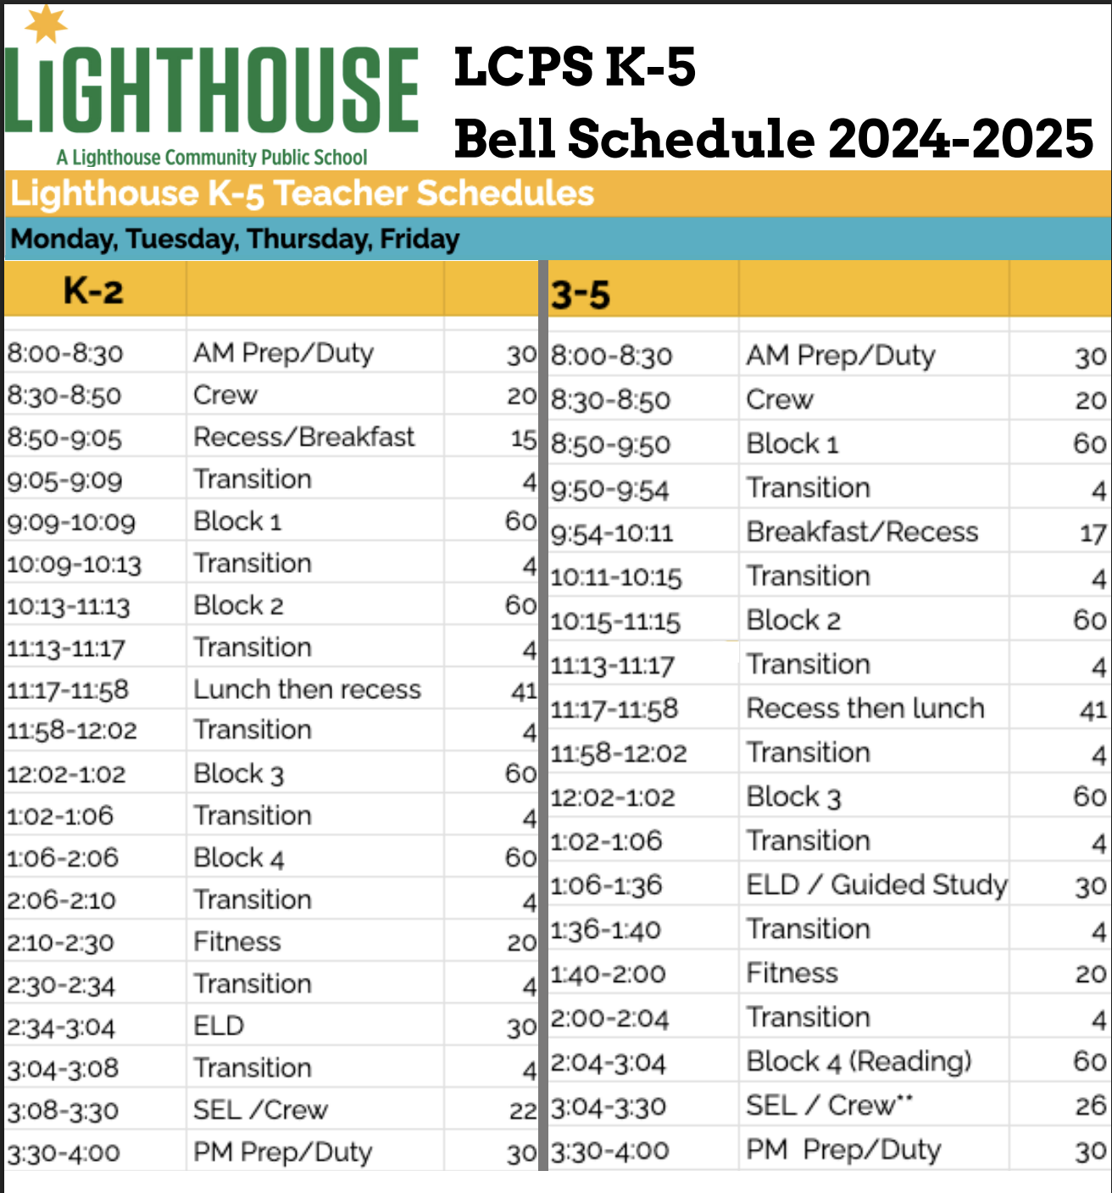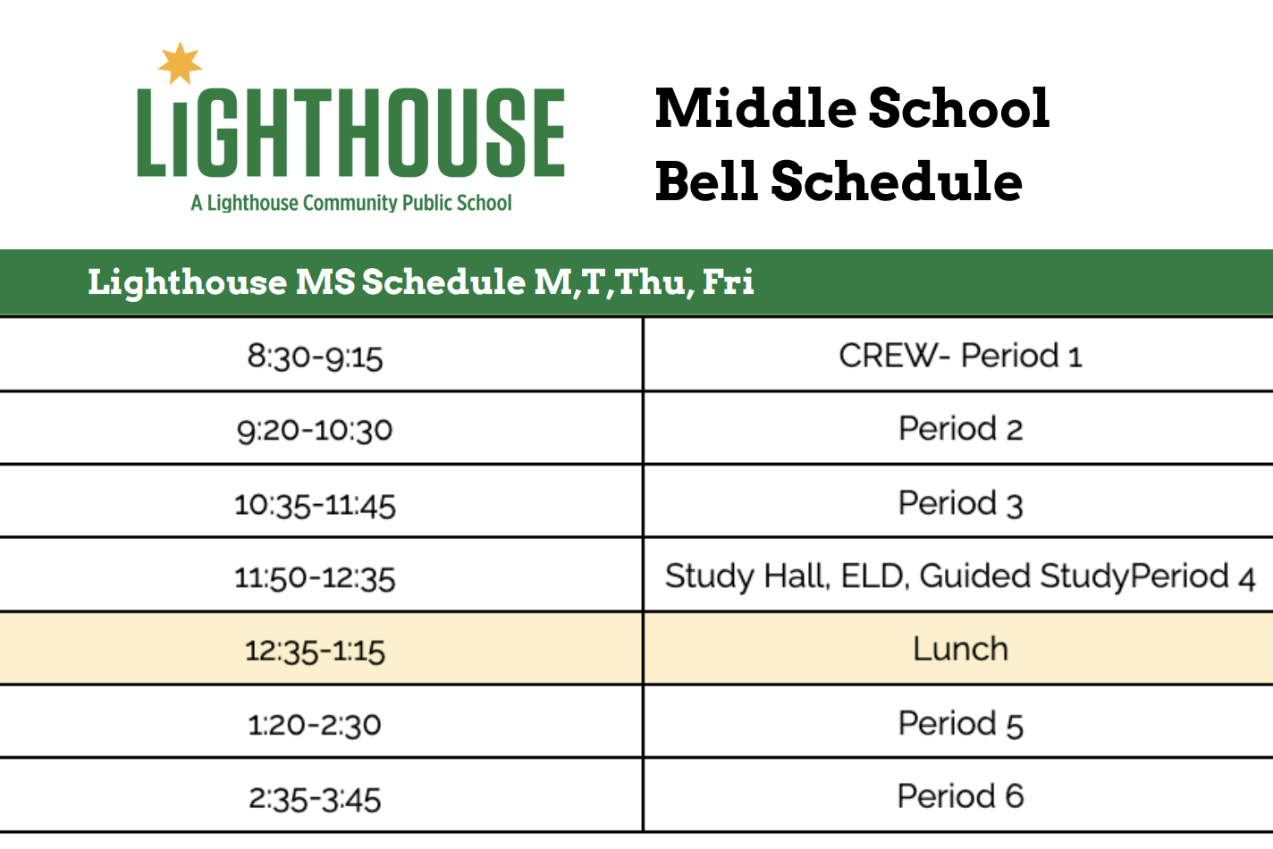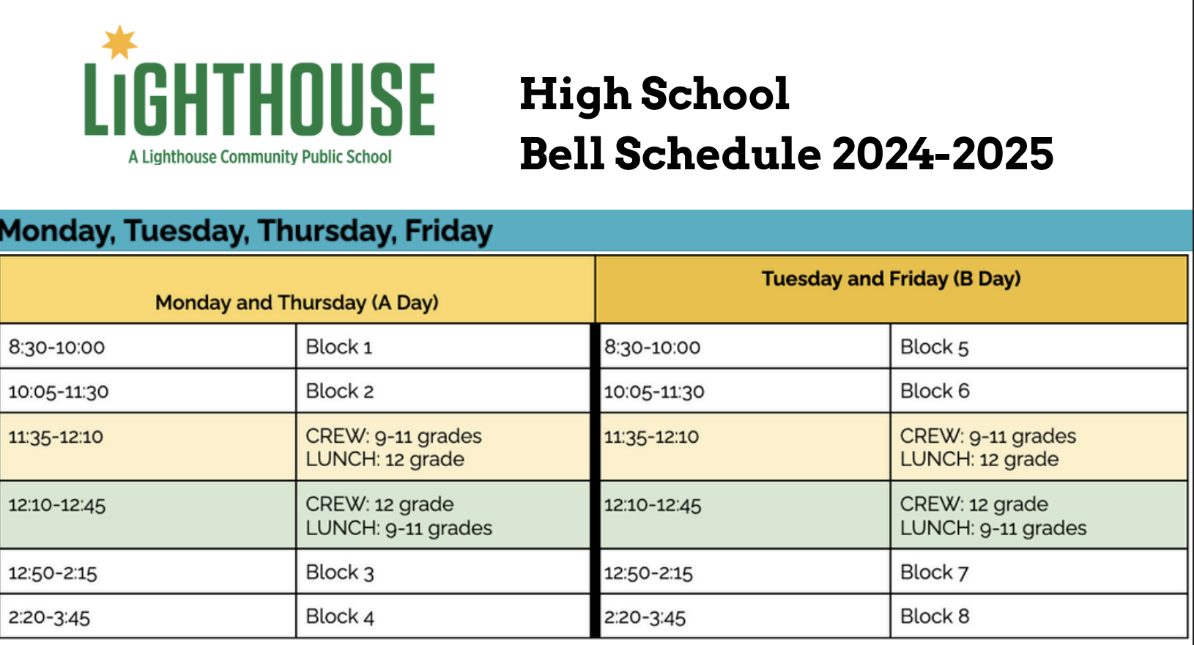

Lighthouse offers the ASP directly after the core day, running 3:30 - 6:00 on all days except Wednesday when it runs 1:30 - 6:30. In total, the after school program will offer 15 hours a week of programming for 36 weeks per year. There are three main components of the program:

1. Enrichment
2. Recess/Fitness/Athletics
3. Homework Support

**Grades TK-5**

| Daylight savings schedule | 3:30 -4:30  Snack & Academic Support | 4:30 - 5:00  Recess | 5:00 - 6:00  Enrichment |
| --- | --- | --- | --- |
| Non Daylight savings schedule | 3:30-4:00  Snack & Recess | 4:00-5:00  Academic Support | 5:00 - 6:00  Enrichment |

**Grades 6-8**

| Regular | 3:45 -4:00  Snack & Academic Intervention | 4:00 - 5:00  Academic Support | 5:00 - 6:00  Enrichment/Athletics |
| --- | --- | --- | --- |

​​**Academic Support:** In our after-school program, students receive personalized academic support to enhance their reading and math proficiency, along with study skills. This targeted assistance addresses the needs identified in our annual survey, such as a lack of home support for content homework and the necessity for soft skills development. Lighthouse is committed to preparing students for college and career success by fostering mastery of key standards and empowering students to take control of their learning.

**Enrichment**: Our after-school program offers daily enrichment activities, providing students opportunities to explore passions, produce high-quality work, and develop 21st-century thinking and design skills. Aligned with the Eight Keys of Youth Development, these activities enable students to discover their identity, face new challenges, experience the pride of mastery, and enjoy life. Through enrichment, students develop agency, honing skills, deepening motivation, and cultivating habits like creativity, innovation, curiosity, collaboration, and communication. Emphasizing cultural exploration and expression, enrichment classes often conclude with final performances, celebrating student culture and positive identity development at the end of each semester.

Students sign up for enrichment classes by choice and based on passions. While some enrichments are offered twice per week (M/Th or T/F), others are offered four times per week (M,T, Th, F). Therefore, students take either one or two enrichment classes per semester. A sample of enrichment classes by functional area are as follows:

* **Fitness** - Basketball, Soccer, Kickball, Boxing, Four Square, Volleyball, Badminton, Flag Football, Biking
* **Dance/Drama** - Yoga, Hip Hop Dance
* **Art/Making** - Robotics, Photography and Graphic Design, 3D Printing, Tye Dye, Cooking,
* **Music** - Guitar and Drums
* **Gaming** - Cooperative Play, Board Games, Electronic Games
* **Language** **Arts**- Writing Club, Poetry
* **Events:**  Spelling Bees, Student Council, Talent Shows, Cultural Celebrations, Art Showcase, After-school Showcase

**Recess:**Recess is similar to time of the core day and is a rotation of three activities: recess, fitness/wellness, and healthy snack designed around student agency and building healthy habits for life.

## Additional Legal Requirements

Below are additional legal requirements for the ELO-P. Please ensure your Program Plan meets all of these legal requirements:

### Operations, Sites, ELO Program Plan, Family Fees, Ratio *EC* Section 46120(b)(2):

Local educational agencies operating expanded learning opportunity programs pursuant to this section may operate a before school component of a program, an after school component of a program, or both the before and after school components of a program, on one or multiple school sites, and shall comply with subdivisions (c), (d), and (g) of Section 8482.3, including the development of a program plan based on all of the following:

1. The department’s guidance.
2. Section 8482.6.
3. Paragraphs (1) to (9), inclusive, and paragraph (12) of subdivision (c) of Section 8483.3.
4. Section 8483.4, except that programs serving transitional kindergarten or kindergarten pupils shall maintain a pupil-to-staff member ratio of no more than 10 to 1.

### Regular Schooldays and Hours EC Section 46120(b)(1)(A):

On schooldays, as described in Section 46100 and Sections 46110 to 46119, inclusive, and days on which school is taught for the purpose of meeting the 175-instructional-day offering as described in Section 11960 of Title 5 of the California Code of Regulations, in-person before or after school expanded learning opportunities that, when added to daily instructional minutes, recess, and meals, are no less than nine hours of combined instructional time, recess, meals, and expanded learning opportunities per instructional day.

### Nonschool Days and Hours EC Section 46120(b)(1)(B):

1. For at least 30 nonschooldays, inclusive of extended school year days provided pursuant to paragraph (3) of subdivision (b) of Section 56345, no less than nine hours of in-person expanded learning opportunities per day.
2. Extended school year days may include in-person before or after school expanded learning opportunities that, when added to daily instructional minutes, recess, and meals, are not less than nine hours of combined instructional time, recess, meals, and expanded learning opportunities per instructional day.

### Prioritizing School Sites *EC* Section 46120(b)(3):

Local educational agencies shall prioritize services provided pursuant to this section at schoolsites in the lowest income communities, as determined by prior year percentages of pupils eligible for free and reduced-price meals, while maximizing the number of schools and neighborhoods with expanded learning opportunity programs across their attendance area.

### Grades Served *EC* Section 46120(b)(4):

Local educational agencies may serve all pupils, including elementary, middle, and secondary school pupils, in expanded learning opportunity programs provided pursuant to this section.

### Partners EC Section 46120(b)(6):

Local educational agencies are encouraged to collaborate with community-based organizations and childcare providers, especially those participating in state or federally subsidized childcare programs, to maximize the number of expanded learning opportunity programs offered across their attendance areas.

### Audit EC Section 46120(c)(1):

Commencing with the 2023–24 fiscal year, a local educational agency shall be subject to the audit conducted pursuant to Section 41020 to determine compliance with subdivision (b).

### Snacks and Meals EC Section 8482.3(d)(1-2):

1. [Local educational agencies] shall agree that snacks made available through a program shall conform to the nutrition standards in Article 2.5 (commencing with Section 49430) of Chapter 9 of Part 27 of Division 4 of Title 2.
2. [Local educational agencies] shall agree that meals made available through a program shall conform to the nutrition standards of the United States Department of Agriculture’s at-risk afterschool meal component of the Child and Adult Care Food Program (42 U.S.C. Sec. 1766).

### Program Capacity, Family Fees, Sliding Scale *EC Section 46120(b)(5):*

Local educational agencies may charge pupil fees for expanded learning opportunity programs provided pursuant to this section, consistent with Section 8482.6.

### Staff Minimum Qualifications, Ratio *EC* sections 8483.4(a) and 46120(b)(2)(D):

The administrator of every program established pursuant to this article shall establish minimum qualifications for each staff position that, at a minimum, ensure that all staff members who directly supervise pupils meet the minimum qualifications for an instructional aide, pursuant to the policies of the school district. Selection of the program site supervisors shall be subject to the approval of the school site principal.

The administrator shall also ensure that the program maintains a pupil-to-staff member ratio of no more than 20 to 1, except that programs serving transitional kindergarten or kindergarten pupils shall maintain a pupil-to-staff member ratio of no more than 10 to 1. All program staff and volunteers shall be subject to the health screening and fingerprint clearance requirements in current law and district policy for school personnel and volunteers in the school district.

### Program Components *EC* Section 8482.3(c)(1)(A–B):

Each component of a program established pursuant to this article shall consist of the following two elements:

1. An educational and literacy element in which tutoring or homework assistance is provided in one or more of the following areas: language arts, mathematics, history and social science, computer training, or science.
2. An educational enrichment element that may include, but need not be limited to, fine arts, career technical education, recreation, physical fitness, and prevention activities.

### Third Party Notifications *EC* Section 8483.4(b-d):

1. When a local educational agency contracts with a third party to operate a program pursuant to this article, the local educational agency shall require the third party to notify the local educational agency by the next working day following, and to submit a written report within seven days of, the occurrence of any health- or safety-related issues, including, but not limited to, issues involving criminal background clearances for employees, building safety, and any event specified in subdivision (c).
2. For purposes of this section, an “event” includes any of the following:
   1. Death of a child from any cause.
   2. Any injury to a child that requires medical treatment.
   3. Any unusual incident or child absence that threatens the physical or emotional health or safety of a child.
   4. Any suspected child abuse or neglect, as defined in Section 11165.6 of the Penal Code.
   5. Epidemic outbreaks.
   6. Poisonings.
   7. Fires or explosions that occur in or on the premises.
   8. Exposure to toxic substances.
   9. The arrest of an employee of the third party.
3. Any other event as specified by the local educational agency.  
   When a local educational agency contracts with a third party, the local educational agency shall require the third party to request from parents or guardians pupil health information, such as whether a pupil has allergies or asthma, before pupil enrollment. Parents or guardians may provide this information at their discretion and are not required to provide pupil health information for the pupil to receive services pursuant to this article.